KAMPALA JUNIOR ACADEMY – KITANTE
P.2 LITERACY I TERM I 2020

NAME: ___________________________________________STREAM: _______
WEEK ONE
OUR SCHOOL AND NEIGBOURHOOD
1. What is the name of your school?
________________________________________________________
2. Write any four people we find at school.
i) _____________________ (ii) ________________________
(iii) _____________________ (iv) _________________________
3. Name these school symbols.
 | KAMPALA JUNIOR ACADEMY |  | 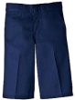  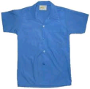  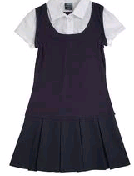

4. State any three examples of non teaching staff in your school.
i) _____________________ (ii) ________________________
(iii) _____________________

5. Write the roles of the following people at school.
a) Teacher ___________________________________________
b) Bursar ___________________________________________
c) Cleaner ___________________________________________

6. Write any six things we get from our neighbourhood.
i) _______________________ (ii) _____________________
iii) _______________________ (iv) _____________________
v) _______________________ (vi) _____________________
7. Who heads a school?
_______________________________________________________
8. Draw these things we in at school.
swings | slides | stones | buses

9. Why do we wear a school uniform?
i) _____________________ (ii) ________________________
iii) _____________________ (iv) _________________________
10. A ________________is the place where school property is kept.
11. Write any four benefits a neighbour gets from the school.
i) _______________________ (ii) _________________________
(iii) _______________________ (iv) _________________________

WEEK TWO
OUR HOME AND COMMUNITY
1. My surname is _________________and I am a ______________ by tribe.
2. A __________________is a group of people related by blood, marriage or adoption.
3. Match correctly.
Children pays bills
Mother help in house work
Father takes care of children

4. Name any four examples of communities.
i) _______________________ (ii) _________________________
(iii) _______________________ (iv) _________________________
5. Complete the table correctly.
Tribe | Language | Traditional wear
Baganda |  | Gomesi
Banyankole | Runyankore
Basoga

6. Write the roles of the people found in our community.
a) A cobbler ______________________________________________
b) A tailor _________________________________________________
c) A carpenter _____________________________________________
d) A pilot __________________________________________________
7. What is a home?
_________________________________________________________
8. Give four examples of things found at home.
i) _______________________ (ii) _________________________
(iii) _______________________ (iv) _________________________
9. Name the two types of families.
i) _________________________ (ii) ________________________
10. Draw these people in an extended family.
Grandfather | Uncle | Aunt | Grandmother

WEEK THREE
THE HUMAN BODY AND HEALTH
1. How many senses do you have?
________________________________________________________

2. Match correctly.
hearing
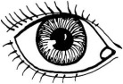
seeing

smelling
3. ________________________is the way we keep the places where we live clean. (Personal hygiene, Sanitation)
4. Mention any one activity a child can carry out to keep the compound clean.
_________________________________________________________
5. Write any two diseases that affect people due to poor sanitation.
i) _______________________ (ii) _________________________
6. What is personal hygiene?
_________________________________________________________
_________________________________________________________
7. Why do we wash our hands before eating food? (Give one reason) _______________________________________________
8. Give any two ways of keeping our hair clean.
i) _________________________________________________________
ii) _________________________________________________________
9. Why do we boil drinking water?
_________________________________________________________
10. Draw these things we use to keep our bodies clean.
Sponge | Soap | Toothbrush | Comb | Towel

WEEK FOUR
FOOD AND NUTRITION
1. ____________________is anything we eat that is useful to our body. (book, food)
2. Circle two main sources of food.
plants trees animals stones
3. Why do people eat food?
________________________________________________________
4. Below are diseases, circle any one disease caused due to poor feeding.
malaria flu kwashiorkor polio
5. A __________________is a meal that contains all food values in their right amount. (water, balanced diet)
6. Name these examples of food.
 |  | 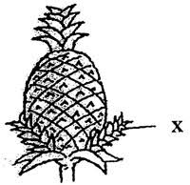 | 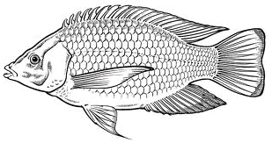

7. Write down any 3 examples of food you eat at home.
i) _______________________ (ii) ________________________
iii) _________________________
8. Who cooks food at home?
_______________________________________________________
9. Why do people go to the market?
_________________________________________________________
10. Give one good eating habit done at home.
_________________________________________________________
KAMPALA JUNIOR ACADEMY – KITANTE
P.2 READING TERM I 2020

NAME: ___________________________________________STREAM: _______
WEEK ONE
1. Write two words for each sound.
a) silent ‘k’ ___________________ _____________________
b) silent ‘m’ __________________ ____________________
c) silent ‘w’ __________________ ____________________
2. Fill the gap with the correct word for sound ‘ea’
a) The ________________advised us to avoid visit friends. (teach, teacher)
b) Musoke likes eating _______________. (blue, bread)
c) This cock has little ________________. (feathers, flowers)
d) It is very cold, wear your _______________. (sweat, sweater)
3. Write these words correctly.
a) cilpen _________________ (b) urler _______________
c) psho _______________ (d) abg ________________
e) twewa ______________ (f) chertea ________________

WEEK TWO
1. Read and draw pictures.
a) Nakabuye is sweeping the compound.

b) The boy has a big bag.

(c) My grandmother is eating an apple.

d) The woman is cooking food.

2. Join the sounds and read the words.
a) m ________________
b ea t ________________
s _________________

b) tak ________________
gat e ________________
mak _________________

c) rite ________________
w rong ________________
rist _________________

3. Name these pictures.
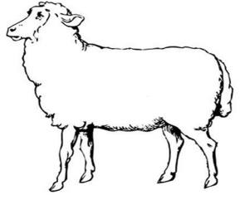 | 

4. Construct correct sentences using these words.
a) knee ___________________________________________________
b) neighbour ______________________________________________
c) kneel ___________________________________________________

WEEK THREE
1. Fill in the missing letters.
a) d___ster (b) ch___lk (c) ru___er
d) he___dt___acher (e) l___mb (f) m___ther
2. Read and write the correct word.
a) I have two horns, you like to eat my meat and drink my milk. What am I? ________________________________________
b) I give light at night but I am not hot. I have a round face and people cannot touch me. What am I?
_____________________________________________________
3. Fill in the correct word for silent ‘b’.
a) My mother cut her _______________when she was peeling bananas.
b) Please call the ________________to come and fix our water pipe.
c) Babirye’s sheep has a brown _______________.

WEEK 4
1. Use the given words to complete the story below.
furniture, sleeping, wood, chair, plates , carpenter

Mr. Lule lives in our community. He is a ___________________. He makes different things out of __________________. He makes _______________for sitting on, beds for _______________on, the cupboards for keeping in our cups and __________________.
Mr. Lule uses good timber and his ______________is liked by many people.
2. Draw Mr. Lule making furniture in his workshop.

3. Make correct sentences from the table below.
This  Those  That  These | beans  meat  trees | is  are | nice.  very tall.  smelling badly.  many.

a) _________________________________________________________
b) _________________________________________________________
c) _________________________________________________________
d) _________________________________________________________

